Programming Exercise 1: Linear Regression

Machine Learning

Student Name: THAI NGUYEN

PeopleSoft ID: 1853385

Question (1)

Please plot the figure of Training data with linear regression fit below:

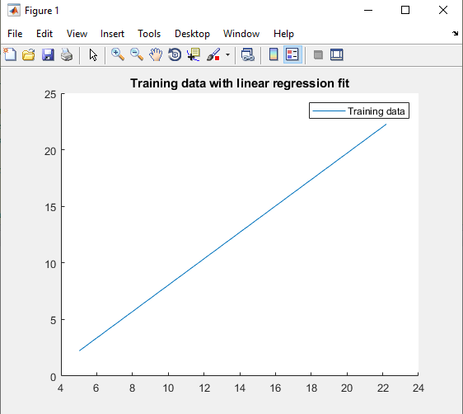

Question (2)

Please give the value of initial cost J when theta are all zeros:

J = 32.072734

Question (3)

Please give the Prediction on profits in areas of 45,000 people:

Profits = 16183.391371